**Objective**: At the end of this lab session, you should be able to write the SELECT command with HAVING clause for single table queries.

Furthermore, you will understand where we can use these functions.

Section 1

HAVING CLAUSE

The HAVING Clause enables you to specify conditions that filter which group results appear in the results.

The HAVING clause was added to SQL because the WHERE keyword could not be used with aggregate functions.

**Syntax**

* **Column1, column2,**

Columns that are not encapsulated within an aggregate function must be included in the GROUP BY Clause before the HAVING clause.

* **aggregate_function**

This is an aggregate function such as the SUM, COUNT, MIN, MAX, or AVG functions.

* **aggregate_column**

This is the column or expression that the aggregate_function will be used on.

* **Table**

The tables that you wish to retrieve records from.

* **WHERE condition**

Optional. These are the conditions for the records to be selected.

* **HAVING condition**

This is a further condition applied only to the aggregated results to restrict the groups of returned rows. Only those groups whose condition evaluates to TRUE will be included in the result set.

Difference between WHERE clause and HAVING clause.

The main difference between WHERE and HAVING clause comes when used together with GROUP BY clause

* WHERE is used to filter rows before grouping
* HAVING is used to exclude records after grouping.

When SQL statements have both a WHERE clause and HAVING clause, keep in mind the WHERE clause is applied first, then the results grouped, and finally, the groups filtered according to the HAVING clause.

Example:

What are the courses which offer more than 2 modules in semester 01?

First of all, you need to check the Offers table by following simple query. Then you can view the full Offers table. It’s helpful to write a suitable query for the above question.



Then we can see following table.

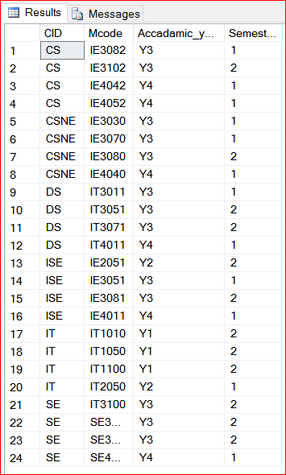

Now you can write down following SQL query to get the answer for the above question.



Then you can see following data set retrieving from the Offers table.

SELECT CID, COUNT(Mcode)

FROM Offers

WHERE Semester =1

GROUP BY CID

HAVING COUNT(Mcode)>2;

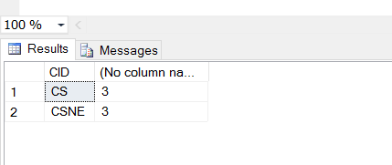

Section 2

Exercise

1. Display the number of students for each course? List the Course_ID of courses only if there are less than 10 students for the course.

SELECT CID

FROM Student

GROUP BY CID

HAVING COUNT(SID)<10;

1. List the Course_ID and the number of modules offered for each course. Display only the course ids which have more than 3 modules offered in it. Sort the result according to the ascending order of the module count.

SELECT CID, COUNT(Mcode)

FROM Offers

GROUP by CID

HAVING COUNT(Mcode) >3

ORDER BY COUNT(Mcode);

1. Display the course id, academic year and the number of modules offered. The number of modules offered should be less than 10.

SELECT CID, Accadamic_year, COUNT(Mcode)

FROM Offers

GROUP BY CID, Accadamic_year

HAVING COUNT(Mcode) <10;

1. List the courses that offer more than 2 modules for year 3 students?

SELECT CID

FROM Offers

WHERE Accadamic_year='Y3'

GROUP BY CID

HAVING COUNT(Mcode)>2;